**Spatial Differences in Fine Particulate Matter and Ozone Exposure among Salt Lake County K-12 Schools and their Impact on Absences**

**Introduction**: The Wasatch Front exhibits bi-seasonal poor air quality with elevated fine particulate matter (PM2.5) during the winter and elevated ozone during the summer. School recess guidance for whether children should be allowed to play outside during recess during the winter currently relies on the observed PM2.5 concentration at 8 AM from the nearest Utah Division of Air Quality (UDAQ) sensor. Currently, there is no established protocol for the summer months. Here we investigate a new method for estimating PM2.5 and ozone concentrations at all schools in the Salt Lake, Granite, Jordan, Canyons, and Murray School Districts, encompassing all of Salt Lake County, using all available research- and regulatory-grade stationary and mobile observation platforms over 3 school years (Fall 2014-Spring 2018). While the impact of poor air quality on school absences is an ongoing topic of study, previous work has rarely studied absences at a more disaggregate level than the encompassing school district and never at the scale of individual schools.

**Methods**: We modeled 5-minute, hourly, and daily-averaged PM2.5 exposure at all schools in Salt Lake County using an inverse-distance weighted approach utilizing data from UDAQ, University of Utah fixed locations, and University of Utah TRAX-mounted mobile sensors. The modeled exposures were compared to following-day school absences at a daily level for each school.

**Results**: Each of the five school districts displayed different trends in PM2.5 and ozone exposure corresponding to subsequent absences. The consistent trend was that more westerly locations generally showed higher levels of PM2.5 and more easterly areas showed higher levels of ozone. However, elevation and proximity to emissions sources were important factors resulting in lower levels of PM2.5 in the southwest portion of Salt Lake County. We determined that specific-school modeled exposure and absences are more highly correlated than that using exposure derived from a single air quality monitor.

**Conclusions**: Our new exposure modeling method using observations from an extensive air quality monitoring network could be used to provide improved recess guidance for schools to protect children’s health. Future work will expand this study to cover the Wasatch Front and compare the modeled exposure to absence data. In addition, poor air quality from ozone that affects students in April through August will be compared to absences for schools participating in summer classes, as well as athletic team practices.

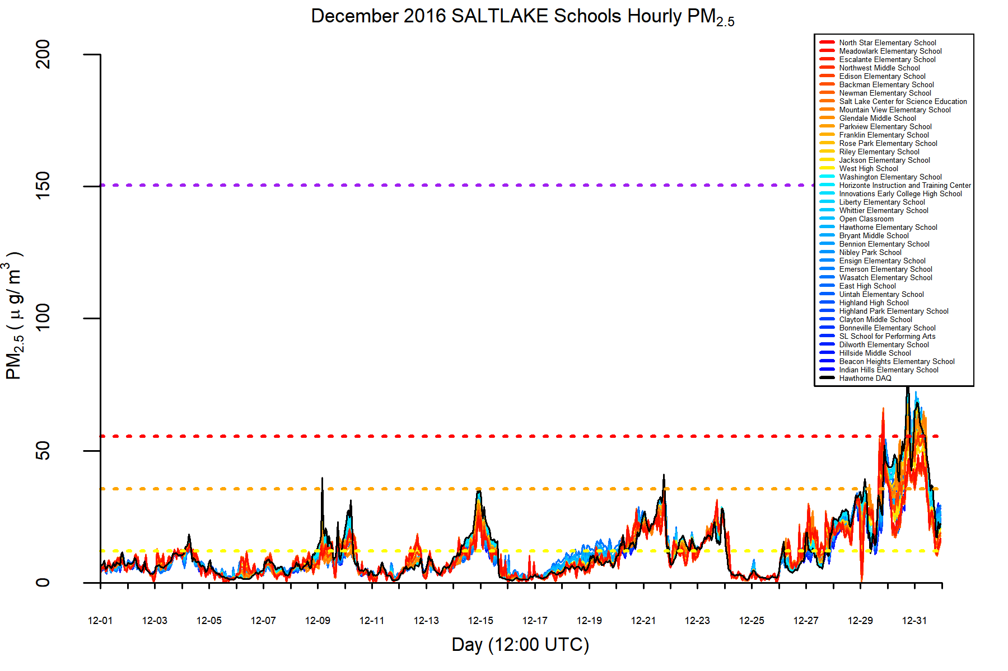

**Figure 1.** Modeled hourly PM2.5 for December 2016 at 38 schools in the Salt Lake School District.

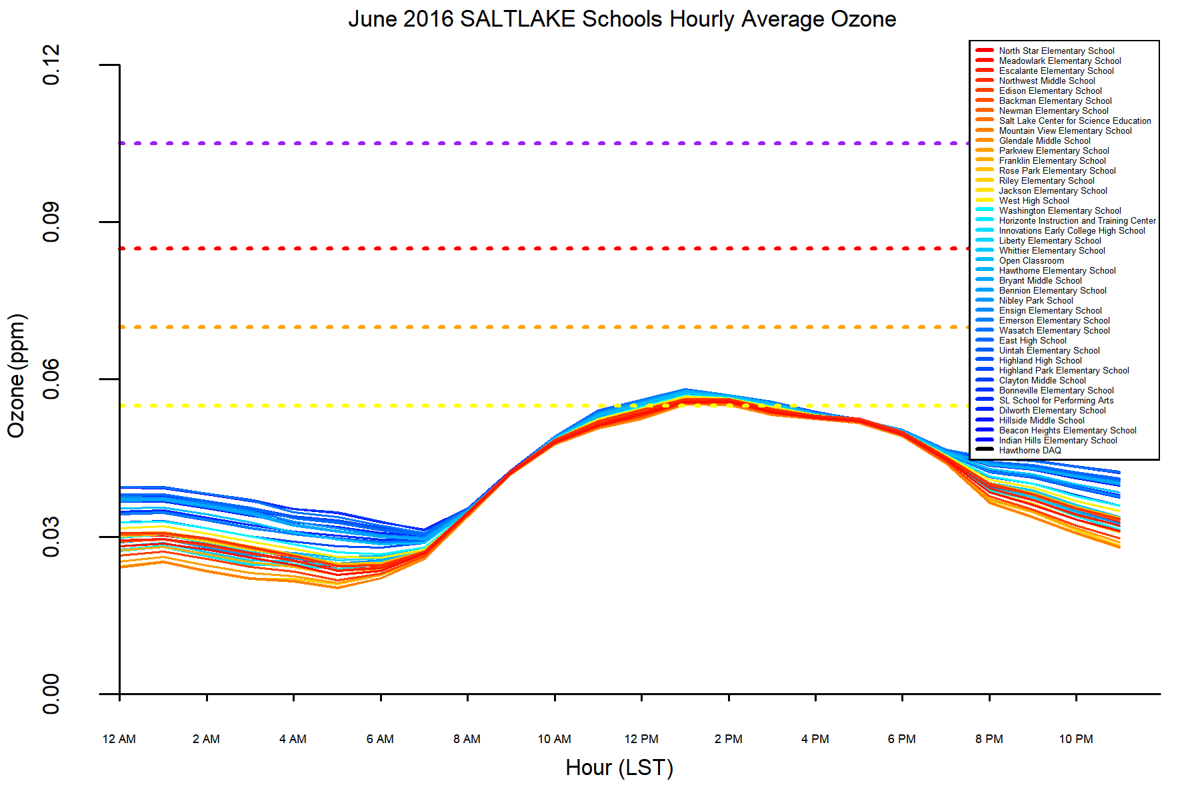

**Figure 2.** Modeled hourly ozone for June 2016 at 38 schools in the Salt Lake School District.